Discovery 17: Configure Static VTI Point-to-Point Tunnels
Introduction

In this task, you will implement a static VTI point-to-point tunnel configuration on the R2 router to enable it to establish a VTI point-to-point tunnel with the R3 router. This will enable hosts at the R2 site and hosts at the R3 site to securely exchange data across the Internet. Hosts on each network will be able to access resources on the other network as if directly connected to the other private network, while benefiting from the functionality, security, and management policies of that private network.
The R3 router is preconfigured to support this lab exercise.
Your configuration tasks are as follows:
- Configure static VTI point-to-point tunnel
- Verify static VTI point-to-point tunnel
Task 1: Configure Static VTI Point-to-Point Tunnel

In this task, you will implement a static VTI point-to-point tunnel configuration on the R2 router to enable it to establish a VTI point-to-point tunnel with the R3 router. This will enable hosts at the R2 site and hosts at the R3 site to securely exchange data across the Internet. Hosts on each network will be able to access resources on the other network as if directly connected to the other private network, while benefiting from the functionality, security, and management policies of that private network.

The R3 router is preconfigured to support this lab exercise.

Activity Procedure

Configure Static VTI Point-to-Point TunnelsEnterprise/CCNP/Enterprise_Core/ENCOR/v1.0/ELT_VIDEOS/ENCOR10_13-08_Implement-Static-VTI-Point-to-Point-Tunnels_001.mp43Play Transcript ID4404687template_version4.1.1Enterprise/CCNP/Enterprise_Core/ENCOR/v1.0/ELT_VIDEOS/ENCOR10_13-08_Implement-Static-VTI-Point-to-Point-Tunnels_001.vtt

Step 1: On the R2 router, create a new IKE policy.
Specify the following parameters:
- Authentication method: preshared
- Encryption algorithm: AES 128
- Hash algorithm: SHA
- Key exchange method: 14
- Lifetime: 1 hour
On R2, enter the following commands:
R2(config)# crypto isakmp policy 10
R2(config-isakmp)# authentication pre-share
R2(config-isakmp)# hash sha
R2(config-isakmp)# encryption aes 128
R2(config-isakmp)# group 14
R2(config-isakmp)# lifetime 3600
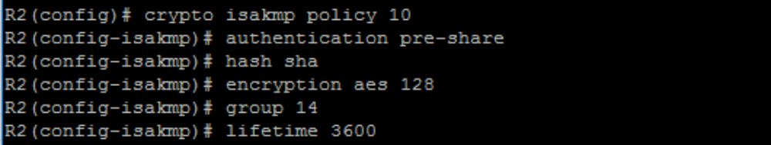

Step 2: On the R2 router, create a PSK and bind it to the IP address of the R3
Router (172.18.4.2).
On R2, enter the following command:
R2(config)# crypto isakmp key cisco address 172.18.4.2

Step 3: The transform set determines the encryption and data authentication hash for the IPSec SA. The transform set must match an equal policy on the peer. On the R2 router, create an IPsec transform set for user traffic protection. Use ESP with 128-bit AES as the encryption transform and use ESP with SHA-1 (HMAC variant) as the authentication transform.
On R2, enter the following command:
R2(config)# crypto ipsec transform-set MYSET esp-aes 128 esp-sha-hmac

Step 4: On the R2 router, create an IPsec profile and include transform set in the profile.
On R2, enter the following commands:
R2(config)# crypto ipsec profile MYPROFILE
R2(ipsec-profile)# set transform-set MYSET

Step 5: On the R2 router, create a new tunnel interface. Configure the interface to use the IP address and subnet of the GigabitEthernet 0/0 interface. Specify a tunnel source (GigabitEthernet 0/0) and a tunnel destination of R3’s GigabitEthernet 0/0 interface IP address (172.18.4.2).
On R2, enter the following commands:
R2(config)# interface Tunnel0
R2(config-if)# ip unnumbered GigabitEthernet0/0
R2(config-if)# tunnel source GigabitEthernet0/0
R2(config-if)# tunnel destination 172.18.4.2


Step 6: On the R2 router, specify IPsec as the tunnel encapsulation. Specify the traffic protection policy by referencing the configured IPsec profile.
On R2, enter the following commands:
R2(config)# interface Tunnel0
R2(config-if)# tunnel mode ipsec ipv4
R2(config-if)# tunnel protection ipsec profile MYPROFILE

Step 7: On the R2 router, create a static route to the R3 internal network (10.10.2.0/24) that is reachable over the tunnel.
On R2, enter the following command:
R2(config)# ip route 10.10.2.0 255.255.255.0 Tunnel0

Task 2: Verify Static VTI Point-to-Point Tunnel

In this task, you will verify the configuration and functionality of your static VTI point-to-point tunnel.

Activity Procedure

Step 1: On the R2 router, verify the status of the IPsec SA. Notice that there are no packets encapsulated or de-encapsulated.
On R2, enter the following command:
R2# show crypto ipsec sa 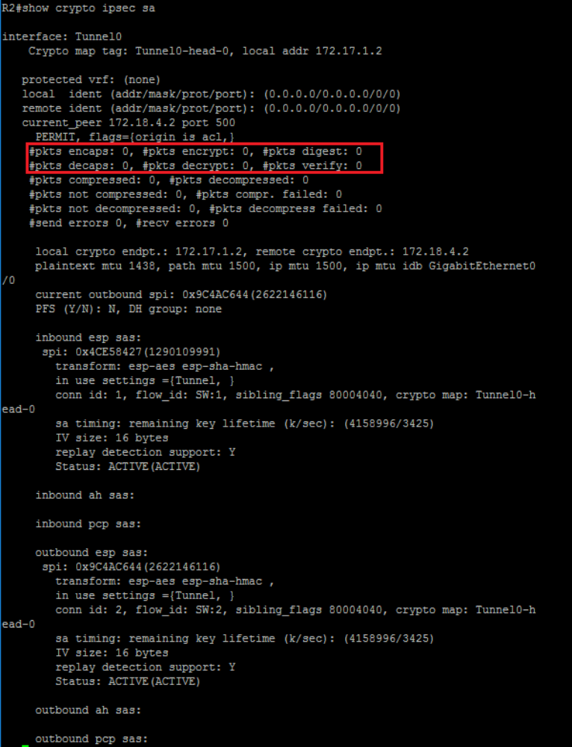
Step 2: On the R2 router, verify the status of the tunnel interface. The tunnel interface should be up/up.
On R2, enter the following command:
R2# show interface tunnel 0 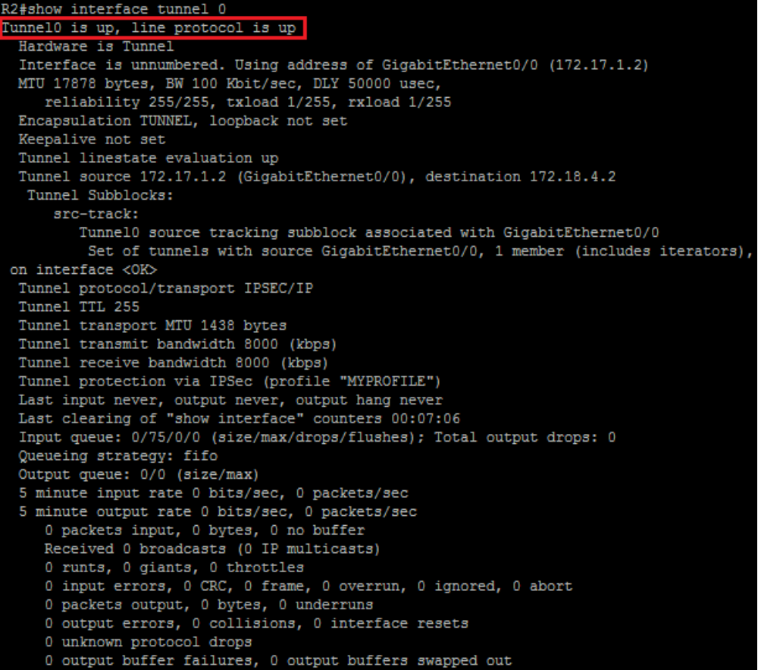

Step 3: On the R2 router, verify the routing table. Network 10.10.2.0/24 should be reachable via Tunnel0 interface.
On R2, enter the following command:
R2# show ip route 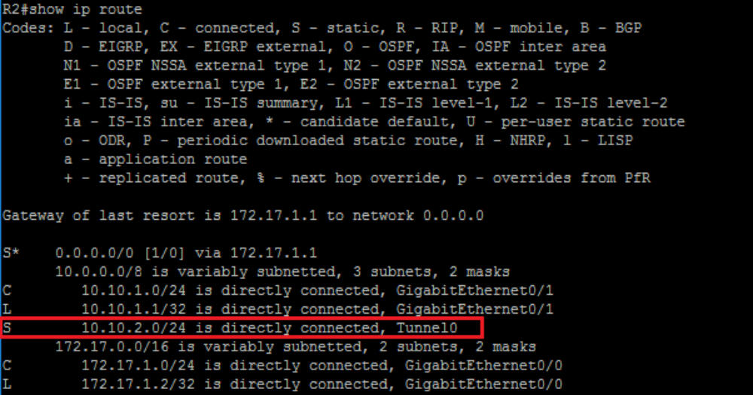

Step 4: Generate a ping from R2's internal LAN interface, Eth0/1, to R3's internal LAN interface address, 10.10.2.1. The ping should be successful.
On R2, enter the following command:
R2# ping 10.10.2.1 source GigabitEthernet 0/1
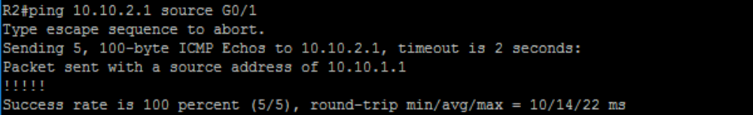

Step 5: On the R2 router, verify the status of the IPsec SA again. Observe that the packet count for encapsulated and de-encapsulated increased by five packets. The static VTI point-to-point tunnel interface is operational.
On R2, enter the following command:
R2# show crypto ipsec sa

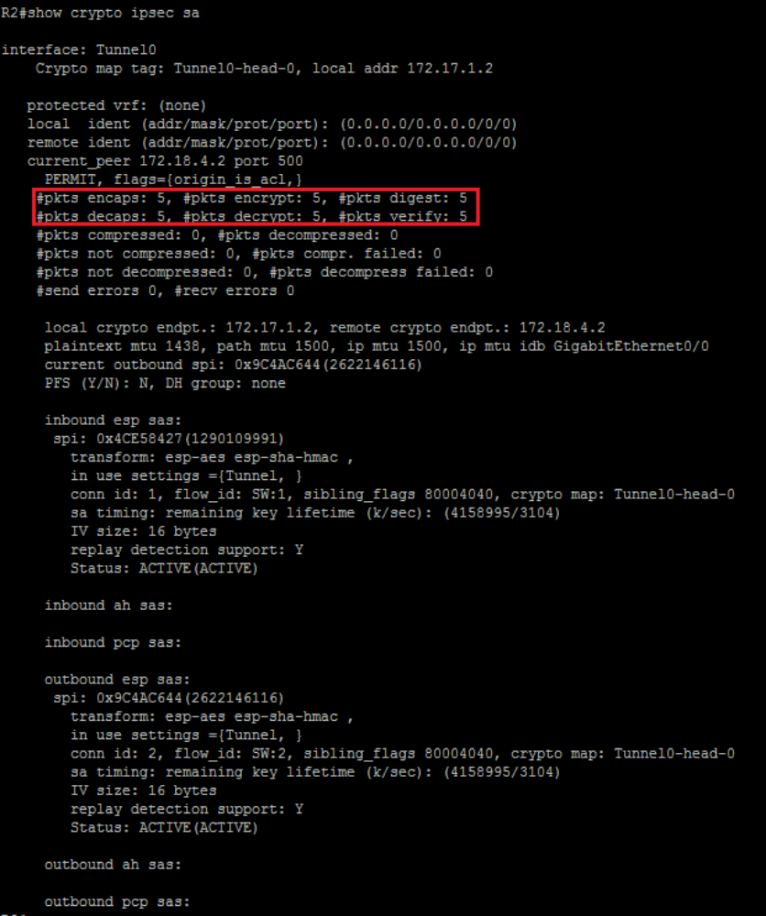

Step 6: On the host PC1, ping the host PC2 at the R3 site (10.10.2.12). The attempt should be successful.
On host PC1, enter the following command:
PC1# ping 10.10.2.12
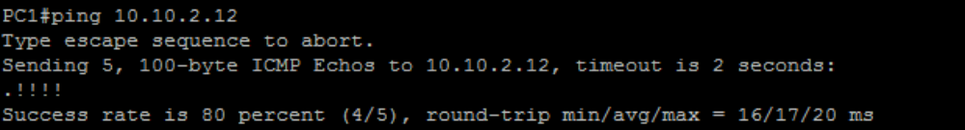
Step 7: On the R2 router, verify the status of the IPsec SA again. Notice that the packet count for encapsulated and de-encapsulated increases again.
On R2, enter the following command:
R2# show crypto ipsec sa
